2.4.1 Continuity

Motivation: We want to call a function continuous if we can draw the graph of the function without picking up our writing utensil.

In class we will sketch some examples of continuous/discontinuous functions.

We now present a rigorous definition of continuity of a function at a point.

Definition: A function f is continuous at a number a if .

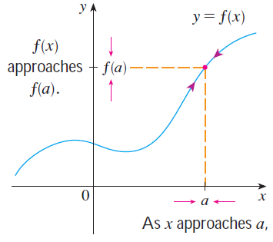
Note: It is very important to note that if one or both sides of the equation defining continuity does not exist, then the function is NOT continuous at a! For example, if the limit is infinite, the function is not continuous at a.

The following picture illustrates the definition of continuity above:

Example 1: The function is pictured below. Would you say that is continuous at 5?

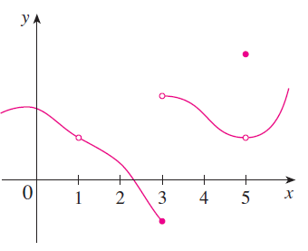

No, based upon the picture it seems that .

Question: What are all of the values of x at which the function
is discontinuous?

is discontinuous at

Example 2: State whether the following function is continuous at 1. Explain your answer.

We note that .
Also, .
Thus, , and the function is continuous at 1 by definition.

Example 3: Prove that the function is continuous 5.

We need to show that . In order for this to be true we need to have the limit exist. Since we can approach 5 using each of the pieces of f we must check the limit from both sides.
We note that and that.
Therefore we can say that
Also, .
Thus, , and the function is continuous at 5 by definition.

Types of Discontinuities

Removable Discontinuities | Infinite Discontinuities | Jump Discontinuities

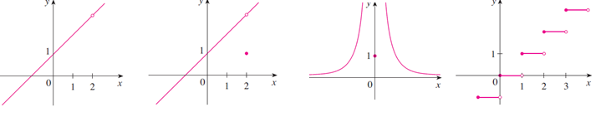
Example 4: Find all the real numbers at which the following function is discontinuous. Also state the type of discontinuity at each number that you find: .

We begin by graphing the function:
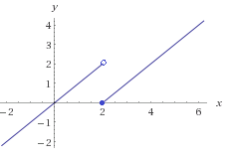

We see (intuitively) from the graph that there is a discontinuity only at 2. Specifically, DNE. Moreover, the discontinuity at 2 is a jump discontinuity.

Example 5: Answer each of the following.
- Give an example of a function with an infinite discontinuity at 4.

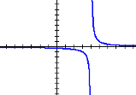
There are many possible examples. We just need at least one of the one sided limits as we approach 4 to be positive or negative infinity. One example is since .

- Give an example of a function with a removable discontinuity at 4.

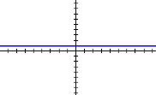
For a removable discontinuity we need the limit of the function as we approach 4 to exist but not equal the function evaluated at 4. One example is . Note that , yet is undefined.

We now introduce some definitions to help us make sense of statements like: “f is continuous on an open/closed interval”.
Definition: A function f is continuous from the right at a if , and f is continuous from the left at a if .

Definitions:
- A function f is continuous on the open interval (a,b) if f is continuous at each number in the interval.
- A function f is continuous on the closed interval [a,b] if the following three conditions hold:
- f is continuous on (a,b)
- f is continuous from the right at a.
- f is continuous from the left at b.

Example 6: Consider the function . The graph of the function is below:
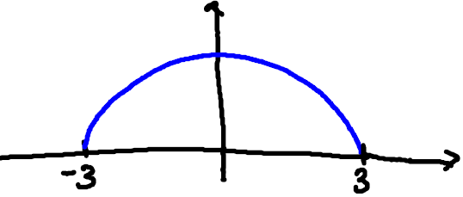

- State the domain of f.

We need . So the domain is all the values of x in . This is also clear from the graph of the function.

- Show that is continuous on its domain.

We must verify the three conditions of the most recent definition. First note that for any c in , we can obtain the following from the limit laws: . This shows that f is continuous on (-3,3).

Again using the limit laws, we note that:
, and
.
So, f is right continuous at -3 and left continuous at 3.
We conclude that f is continuous on the closed interval [-3,3], and hence f is continuous on its domain.

We now present two theorems which will help us determine when functions that we are familiar with from Precalculus are continuous.
Theorem: If and are continuous at a and c is constant, then the following functions are also continuous at a:
- 2. 3.

4. 5. if
Proof (of 1):
We know that since and are continuous at a, and . So, using the first limit law, we have that: .

Note: The proof of statements 2, 3, 4, and 5 are similar to the proof of statement 1.
Theorem: The following types of functions are continuous at every number in their domains.

- Polynomial Functions
- Rational Functions
- Root Functions
- Trigonometric Functions
- Inverse Trigonometric Functions
- Exponential Functions
- Logarithmic Functions

Example 7: Use the two most recent theorems to determine where the function: is continuous.

We first note that domain of is all positive real numbers, and the domain of is all real numbers. Thus, by the two most recent theorems is continuous on the interval . Moreover, the function is continuous on the set of real numbers, and .

So, it follows that the function is continuous on . In words, is continuous on the set of positive real numbers with one excluded.

Note: Another way of writing the inverse tangent function is . One should note that this is NOT to be interpreted as tangent to the negative first power. We write tangent to the negative first power as .

Example 8: Find a value of C that makes g continuous on .

We know that g is continuous on the interval because is a polynomial function.
We know that g is continuous on the interval because is the sum of an exponential function and a polynomial function.
We must find C so that g is continuous at . In particular, we need .

We note that and . Moreover,
If , then and therefore we would have

Since we can say that g is continuous at . Therefore g is continuous on.

Example 9: Consider the function: .
- State where this function is continuous.

We note that the domain of the sine function is the set of real numbers. So, the sine function is continuous everywhere. Similarly, is the sum of two functions continuous everywhere. So, g is continuous on all real numbers. Moreover, since for all values of x, g is never 0. Therefore, the function in question is continuous on the set of real numbers.

- Evaluate (be exact).
By part (a) the function is continuous at . So, .

Note: We are more or less using a generalization of the direct substitution property from section 2.3.1 in (b). In particular, if we are trying to find , and we know that f is continuous at a, then the limit can be found by simply plugging a in for x (i.e. finding ).

Question to the Class: How might you approach evaluating the limit: ?

Answer (partial): One might hope to bring the limit inside the inverse sine function, but can we do this? In particular, is it true that ? The next theorem addresses this.

Theorem: If is continuous at b and , then .

Note: The theorem above immediately implies that if g is continuous at a and f is continuous at g(a), then is continuous at a as well.

Example 10: We can use the theorem above to evaluate the limit mentioned in the question above. Specifically,

Example 11 (if time permits): Where is the function continuous?

We know that the natural log function is continuous on the set of positive real numbers, and is continuous on the set of real numbers. So, the function will be continuous as long as . We note that and if and only if . Thus, the function is discontinuous when x is an even multiple of pi, and it is continuous on the intervals between these values.

Note: This is particularly impressive, because this function has infinitely many discontinuities. One can confirm this solution with the graphing calculator.

